Pico Walk Audit Findings
May 16, 2025
Pico Walk Audit Findings
The Pico Walk Audit was held on May 7th from 9:45am to 11:20am. The purpose of the walk audit was for the Community First Engagement project team to gain a deeper understanding of the street conditions and experience to inform the Pico engagement plan. The walk audit took place along a 1 mile stretch of Pico, from Bonnie Brae to Cataline St. The walk audit segment was further divided into three segments:
• Segment 1: Bonnie Brae St to Magnolia
• Segment 2: Magnolia Ave to Vermont Ave
• Segment 3: Vermont Ave to Catalina St
13 people participated in the walk audit. While walking the segments of Pico Blvd, participants were asked to record their observations. The following text summarizes observations of each segment based on the participant’s feedback.
Segment 1: Bonnie Brae St to Magnolia Ave
Segment 1 exhibited significant pedestrian safety and accessibility challenges, including frequent midblock crossings, faded or missing crosswalks, hazardous sidewalk conditions, and speeding vehicles. Participants also noted environmental concerns, limited parking, and heavy foot and vehicle traffic near schools, churches, and commercial areas.
Frequent Midblock Crossings and Speeding Hazards
Participants observed high levels of pedestrian activity and several safety and accessibility concerns. Several pedestrians and bicyclists were seen crossing Pico outside of crosswalks, particularly at the east side of Bonnie Brae where no crosswalk exists. Crosswalks at various intersections, including Magnolia, were either unmarked or faded, and some locations, such as near University Prep Value High School, had no crosswalks at all despite heavy foot traffic. Traffic was fast-moving throughout the corridor, with speeding cars observed at Bonnie Brae, Hoover, and Alvarado.
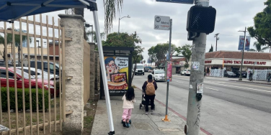Figure 1. Pedestrian walking along Pico Blvd.
P
Hazardous Sidewalks and Obstructions Impacting Accessibility
Sidewalk conditions varied but were frequently described as hazardous, with lifted, cracked, or uneven pavement reported between Westlake and Alvarado, and again near Arapahoe and Hoover.
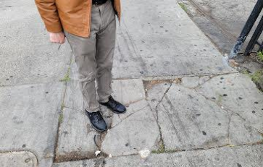Figure 2. Walk audit participant standing on cracked sidewalk.
Some sidewalks were obstructed by vendors, store displays, tables, and parked e-scooters, particularly near busy commercial spots like Ross Dress for Less and along intersections such as Westlake, Alvarado, and Hoover. Multiple locations lacked curb ramps or had missing ADA warning pads, and sidewalks were noted to be narrow or congested in several sections. Alleyways, especially those near the Salvation Army and between Arapahoe and Hoover, were flagged as areas of concern due to surface conditions and unclear pathways.
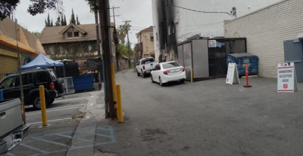Figure 3. Alleyway near Salvation Army.
P
High Vehicle and Pedestrian Traffic and Environmental Concerns
Additional observations included high volumes of vehicle and pedestrian traffic around Ross and nearby churches, crowded bus stops, and active school drop-off and pick-up areas near 1929 Pico. Participants also noted environmental concerns such as street noise, visible trash, poor air quality, and a large curb radius at Westlake making pedestrian crossings feel exposed. Trees were reported as overgrown in some areas, with cracked sidewalks nearby and empty tree wells present. Parking was described as limited and difficult to find, with multiple comments pointing to competition for space near community destinations.
Segment 2: Magnolia Ave to Vermont Ave
Segment 2 was marked by numerous pedestrian safety issues, including cracked and uneven sidewalks, obstructions from vendor setups and encampments, and a lack of ADA-compliant features. Participants also observed malfunctioning traffic signals, abandoned EV charging stations, and high vehicle speeds, leading to discomfort and unsafe conditions for pedestrians, despite some infrastructure improvements like bike parking and street cleaning efforts.
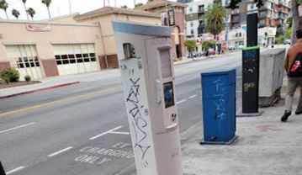Figure 4. Abandoned EV charging station.
Sidewalk Hazards and Obstructions Affect Pedestrian Movement
Throughout Segment 2, from Magnolia Avenue to Vermont Avenue, participants reported a wide range of physical and environmental conditions impacting pedestrian comfort and safety. Sidewalk hazards were common, with lifted and cracked pavement noted in multiple locations including between Westmoreland and Elden, at Menlo, Orchard, and from Vermont to Menlo. Several areas lacked ADA-compliant features, such as curb ramps—especially at the southeast corner of Westmoreland—and there were repeated mentions of narrow sidewalks not accommodating two-way pedestrian flow. Sidewalks were also blocked by bulky furniture, carts, large vendor setups, and personal belongings from encampments, notably near Menlo Avenue and the post office at Westmoreland. These obstructions, combined with high pedestrian volumes (including people carrying laundry, using wheelchairs, or pushing strollers), often forced individuals to walk close to or
P
in the street. The laundromat, Pico 2 Coin Laundry, at Menlo was a frequent point of use, and many were observed pushing their laundry carts along Pico.
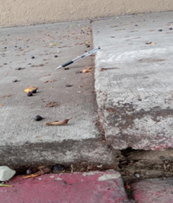
Figure 5. Lifted sidewalk with pen for scale, highlighting surface hazards.
Non-Functional Traffic Infrastructure and Dangerous Intersections
The corridor included a mix of active uses such as a busy laundromat, gas station, car wash, abandoned EV charging stations, and street vendors selling food and household items. A large encampment was noted near Menlo, and the area between Westmoreland and Pico had a heavy presence of scooters, carts, and dockless bikes, some abandoned on the sidewalks. Participants observed non-functioning pedestrian and traffic signals. These included including a red hand signal that was not working on the northbound east side at Westmoreland, a pedestrian signal was stuck on the walking man icon, and a non-operational speed feedback sign near Vermont. The intersection at Vermont and Pico was described as very busy, with fast-moving traffic in all directions. One person witnessed a car running a red light and making a left turn at Westmoreland. There were also road closures, such as Elden Avenue being blocked by planters, and alleyways were mentioned as sites for vehicle turning and U-turns, raising safety concerns. Observations indicated the presence of potholes, uneven streets, and overgrown tree roots, particularly around Magnolia and between Vermont and Menlo. The intersection of Pico and Westmoreland was flagged for poor curb ramp design and crosswalk placement, which contributed to pedestrian exposure and discomfort when crossing. Several noted that people crossing the street had very limited space, as vehicles passed very closely.
P
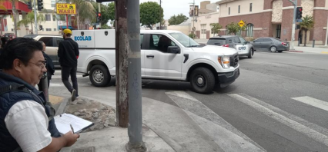Figure 6. Southeast corner of Pico and Westmoreland.
Moderate Comfort Levels Despite Infrastructure Improvements and City Services
Although some improvements like designated bike parking and EV stations were present, the environment was described as only moderately comfortable, with overall ratings ranging from 5/10 to 8/10. The mixed impressions were attributed to street cleaning efforts possibly tied to a Business Improvement District (BID) and a visible city infrastructure presence, such as Fire Station 13 near Westmoreland.
Segment 3: Vermont Ave to Catalina St
In Segment 3, participants reported significant pedestrian discomfort due to cracked sidewalks, obstructions, and poor street conditions. Although public transit infrastructure was present, the area was described as moderately comfortable, with challenges like inadequate lighting, unsafe intersections, and fast-moving traffic compromising pedestrian safety and convenience.
Pedestrian Comfort Compromised by Sidewalk Damage and Obstructions
In Segment 3, from Vermont Avenue to Catalina Street, participants observed continued issues with pedestrian infrastructure and general street conditions. Sidewalks were frequently lifted, cracked, or broken, particularly between Vermont and New Hampshire, presenting hazards for pedestrians and wheelchair users. The sidewalks were also described as narrow and cluttered, with vendors, bulky items, and boxes from local businesses, such as a furniture store near Berendo, taking up walkway space. Many pedestrians were present in this segment, but the sidewalk width often did not accommodate the foot traffic comfortably.
P
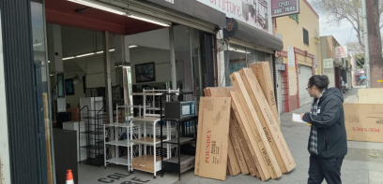Figure 7. Boxes reducing sidewalk space.
Street Conditions, Poor Lighting, and Unsafe Intersections
Several locations had potholes, uneven street surfaces, and cracked asphalt, especially near Catalina and between Vermont and New Hampshire. Street lighting was reported as poor, with one open electrical box noted and concerns about the area being very dark at night. Observers mentioned wire theft from utility infrastructure, and damaged or exposed electrical fixtures, including at a nearby fire station. Crosswalks were faded or in poor condition, particularly at the Vermont intersection, and one speed feedback sign near Vermont was not functioning. There were also complaints about not having enough time for pedestrians to cross at intersections like Catalina.
Public Transit Infrastructure and Overall Comfort
Traffic observations included fast-moving cars and instances of unsafe vehicle behavior, including drivers going straight through intersections from incorrect lanes at New Hampshire. Scooters and skateboards were seen riding on sidewalks, adding to congestion and safety concerns. Despite some areas feeling slightly wider—particularly between Catalina and Berendo—the overall pedestrian environment was limited by sidewalk quality, lighting issues, and vehicle behavior. Public transit infrastructure such as Metro’s 754 Rapid Line and several bus stops were present, though some were noted as needing general improvement. Participants described the segment as moderately comfortable but marked by several physical and environmental challenges.
P
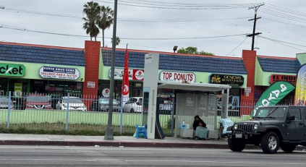Figure 8. Presence of public transit infrastructure.
Summary
The Pico Walk Audit, conducted in three segments from Bonnie Brae Street to Catalina Street, revealed consistent issues affecting pedestrian and cyclist safety, accessibility, and comfort. Participants across all segments reported damaged or uneven sidewalks, faded or missing crosswalks, and frequent obstructions from vendors, bulky items, and encampments, making navigation difficult—especially for people using mobility devices. Bicyclists were often seen riding on sidewalks or against traffic due to a lack of dedicated bike infrastructure, and scooters and dockless bikes frequently blocked pedestrian paths. Speeding was a major concern throughout the corridor, with multiple reports of fast-moving vehicles and unsafe driver behavior at intersections. Poor lighting, non-functioning pedestrian signals, and exposed electrical fixtures added to the safety risks. While some amenities like bus stops, bike parking, and EV charging stations were present, the chargers appeared abandoned and underused. Overall, conditions were described as only moderately comfortable due to persistent issues with traffic behavior, sidewalk congestion, and inadequate space for both walking and biking.
P

